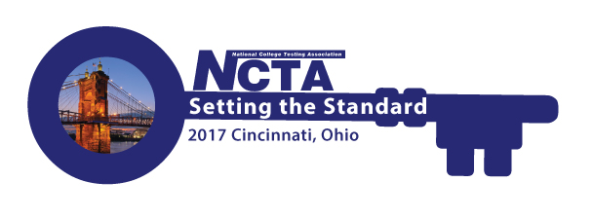
NCTA 2017 Annual Conference Committee Meeting
Monday, April 17, 2017
2:00 PM Eastern Time
GoToMeeting
Minutes

Attendance: Jody Atkins, Cindy James, Alex Martinez, Sally Carter, David Espinoza, Paula Doughman, Duane Goupell, Mary Vaughn, Theresa Scott, Tabatha Phillips, Sally Frazee, Bob Lang, Jamila Maxie, Jarret Dyer, Amystique Church

Programs

Bob reported that the Programs Committee has gone through the first wave of proposals and accepted 41 sessions. They are now going through second wave of people. We have potential 60 spots, but looking at reducing that number. This doesn’t include sponsor workshops, pods, or other special sessions.

Paula talked about, “Run, Hide, Fight.” The Cincinnati police will be doing a session about self-defense and campus security.

Keynote Presentation – Meghan Grace does not want recording distributed to non-attendees. Jim will go back to Meghan and get a revised contract to Jody for signature.

Bob reported that there are two travel scholarships this year.

Bob will send a program agenda later this week.

Virtual Conference – David Espinoza
Presenters have been selected and notified.

Sponsorship Update - Jody
We have several verbal commitments. Will have a more detailed report.

Resource Fair – Jamila Maxie
Will be sending an email out mid-May to state and regional organizations.

Host Committee – Paula Doughman
Plans underway for Welcome Reception with Octoberfest theme. Has information on baseball game and Cincinnati Octoberfest. Would have to purchase a minimum of 20 tickets. When people start registering, let them know about it then. Jarret suggested adding more information on the website about optional entertainment. Dinner groups got reservations already made. The 2018 conference – getting ready for presentation.

Conference App – Amystique Church
Coming along well. Have the preliminary schedule of how they are going to assist people at the conference.

Conference Planner Update – Jody Atkins
Please send website content to Jody.

Conference Budget - Cindy
Cindy asked if there was anyone who needed extra money. Consensus was no.

Tabatha – Do we have an archive of how many first time attendees we have? Tends to be about 1/3.

With no further business, the meeting was adjourned.

